LOR general cable list description

Document Number: E-MAO-PN0-INA-TNO-003

Document Version: 01D1

Document Type: TNO

Released On: 2024-04-15

Owner : | Tommaso Lapucci |  | 15-04-2024
Approved by PI: | Paolo Ciliegi | 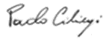 | -04-2024
Released by PM: | Andrea di Rocco |  | -04-2024
 | Name | Signature | Date

Authors
Name | Affiliation
Tommaso Lapucci | INAF-Arcetri
Marco Bonaglia | INAF-Arcetri

Change Record from previous version
Date | Affected Section(s) | Changes / Reason / Remarks
 | All | First issue

Contents

1. Introduction 4
1.1 Purpose 4
1.2 Scope 4
1.3 Definitions, Acronyms and Abbreviations 4
2. Related Documents 5
2.1 Applicable Documents 5
2.2 Reference Documents 5
3. Introduction 6
4. Cable list between +ICS03/+ICS04 and +LOR 10
4.1 Destination : +WFS01 and +UB1 12
4.2 Destination : +WFS02 and +UB2 16
4.3 Destination : +WFS03 and +UB3 20
5. LOR cable list through the cable wrap 24
6. LOR cable list between cabinets 25
6.1 LOR cable list between cabinets ICS04 and ICS05 26
6.2 LOR cable list between cabinets ICS04 and ICS03 27
7. LOR cable list from ICS04 to WDM 28

Introduction

Purpose
This technical has the purpose to give a short description of the cables needed for the LOR WFS.

Scope

Definitions, Acronyms and Abbreviations

AO Adaptive Optics
ELT Extreme Large Telescope
ESO European Southern Observatory
FoV Field of View
IFW Instrument Control Framework
HW Hardware
INAF Istituto Nazionale di Astro Fisica
INS Instrumentation Software
LGS Laser Guide Stars
LOR Low Order and Reference
MCAO Multi Conjugate Adaptive Optics
MICADO Multi-AO Imaging Camera for Deep Observations
MORFEO Multiconjugate adaptive Optics Relay For ELT Observations
NGS Natural Guide Star
NGSA/CA Natural Guide Star Acquisition/Collision Avoidance
OPC/UA Open Platform Communications/Unified Architecture
PLC Programmable Logic Controller
SW Software
TBD To Be Defined
WFS WaveFront Sensor
WDM Water Distribution MORFEO

Related Documents

Applicable Documents
The following applicable documents form a part of the present document to the extent specified herein. In the event of conflict between applicable documents and the content of the present document, the content of the present document shall be taken as superseding.
AD1 ESO-262825_1 E-ELT Electrical and Electronic Design Requirements

Reference Documents
The following documents, of the exact version shown herein, are listed as background references only. They are not to be construed as a binding complement to the present document.

Introduction
The LOR Electronics is hosted in two of the co-rotating cabinets placed on the co-rotating platform of MICADO: ICS04 (where it shall not exceed a volume equivalent to 25U) and ICS03 (where it shall not exceed a volume equivalent to 6U). The block diagram of figure 1 gives an overview of all the connections between these cabinets and the LOR devices.
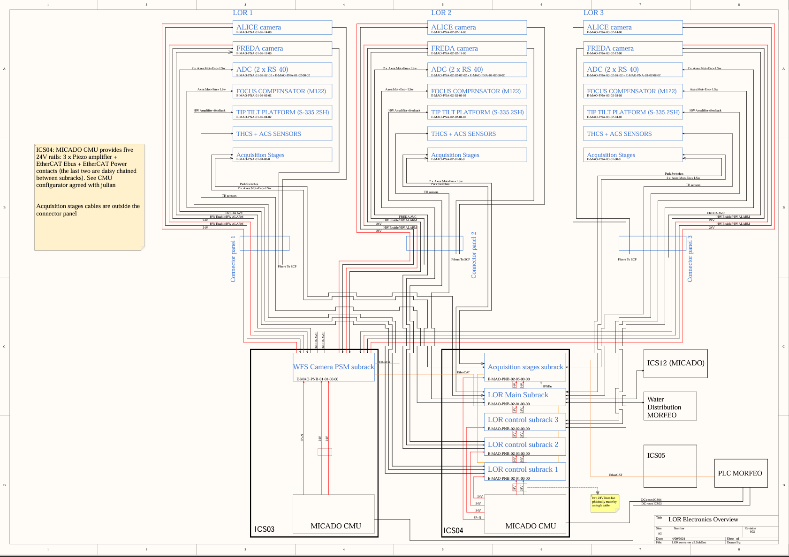
Figure 1 LOR electronics block scheme
The aim is to address the encumbrance of the cables that will be installed in the MCIADO volume and the routing of the connectors passing through the MICADO central flange .

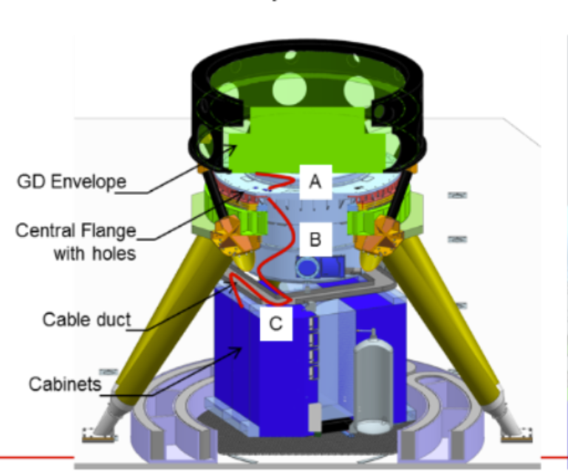
Figure 2 Cable path from cabinets to GD envelope where the LOR devices are installed.
All the cables selected for the LOR WFS are following the fire properties EN60332-1/3 according to the electronic standard mentioned in AD1.
In what follows we will make use of the MICADO location identifier legend ( shown in figure 2).

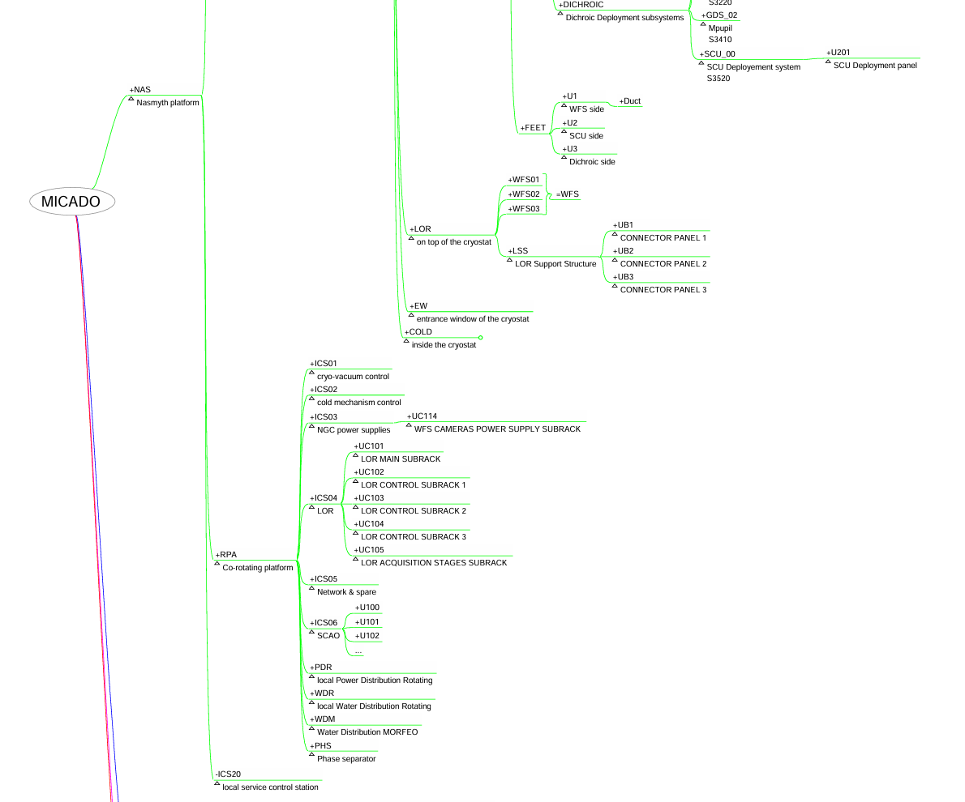
Figure 3 LOR section of the MICADO location identifier

Cable list between +ICS03/+ICS04 and +LOR
This chapter describes the routing between the three connectors panels placed on the LOR support structure and the subracks placed in ICS03 and ICS04 cabinets.
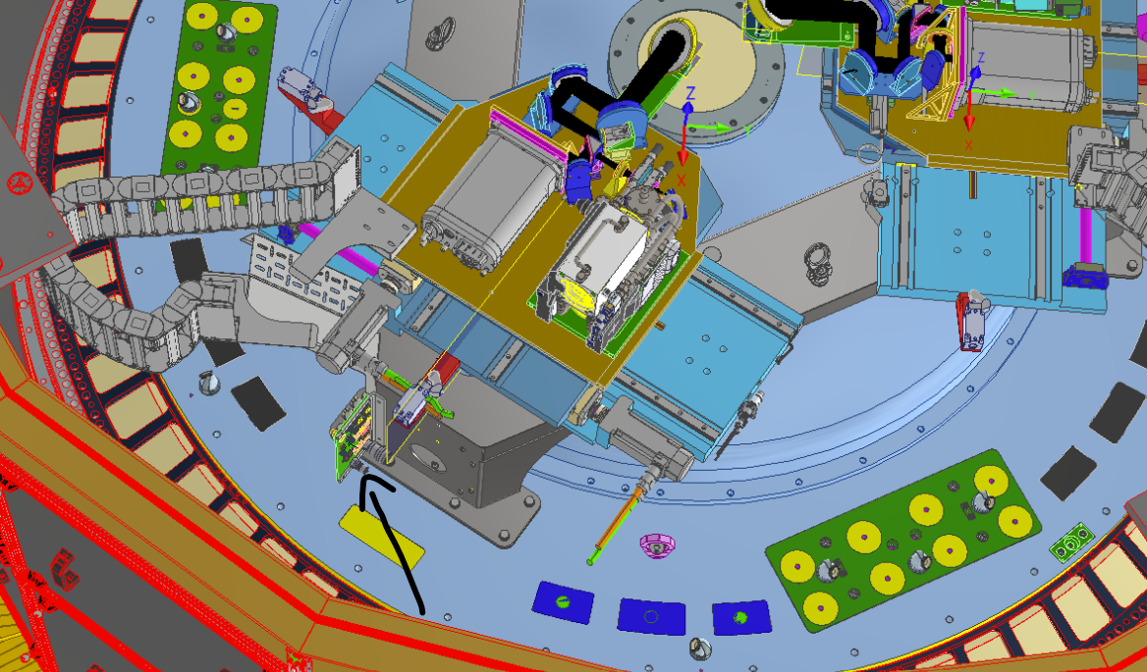
Figure 4 3D view of a LOR with the connector panel pointed by the arrow
Most of the cables will have a sectioning of at the connector panel while a few will go directly from the cabinets to the LOR devices.

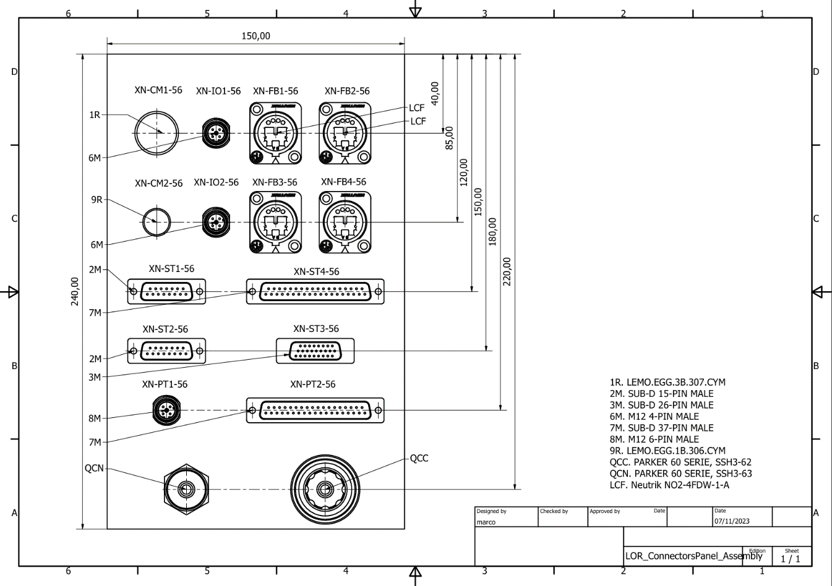
Figure 5 2D view of the connector panel
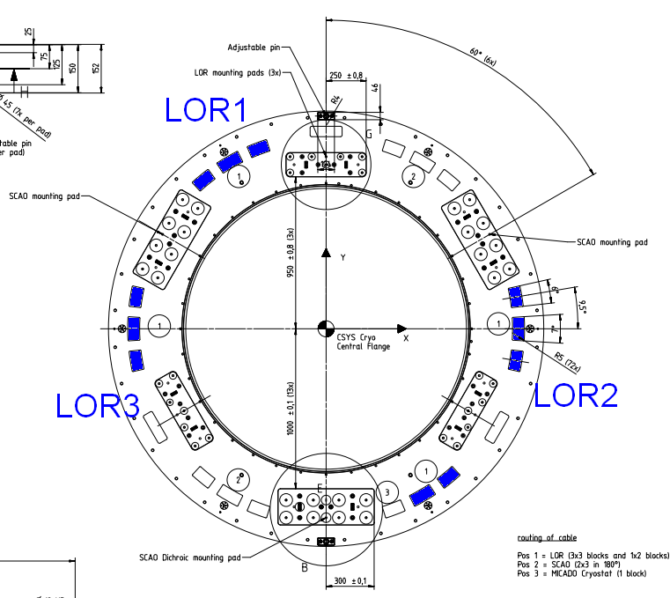
Figure 6 MICADO Central flange

Destination : +WFS01 and +UB1

Device/function | ID | Type of signals | Number of wires x wire diameter [mm2] | Cable PN/ section/ bending radius | SOURCE | DESTINATION
AcqStages |  | Ctrl out  To motor phases | 5 | Kollmorgen DE-87792  ∅ 11 mm  10 x outer diameter | +UC105 | +WFS01
 |  | Feedback on motor + hall | 17 | Kollmorgen DE-107915  ∅ 10 mm  10 x outer diameter | +UC105 | +WFS01
 |  | Limit + lin. Encoder | 18x0.14mm^2 | LAPP Unitronic LiYCY 0034318  ∅ 7,3 mm  15 x outer diameter | +UC105 | +WFS01
Interlock Park switches X and Y |  | 24V contacts | 8 x0.25mm^2 | LAPP Unitronic LiYCY 0034408  ∅ 7,1 mm  15 x outer diameter | +UC101 | +WFS01
Focus Comp. |  | DC motor,  Encoder,  Limit switches | 16 x0.34mm^2 | LAPP Unitronic LiYCY 0034515  ∅ 9,4 mm  15 x outer diameter | +UC102 | +UB1
Pupil St. Mirror |  | HV & strain gauges | 30x0.34mm^2 | LAPP Unitronic LiYCY 0034530  ∅ 12,3 mm  15 x outer diameter | +UC102 | +UB1
ADC  rotary stage 1 |  | DC motor,  Encoder,  Limit switches | 16 x0.34mm^2 | LAPP Unitronic LiYCY 0034515  ∅ 9,4 mm  15 x outer diameter | +UC102 | +UB1
ADC  rotary stage 2 |  | DC motor,  Encoder,  Limit switches | 16 x0.34mm^2 | LAPP Unitronic LiYCY 0034515  ∅ 9,4 mm  15 x outer diameter | +UC102 | +UB1
Sensors box |  | T, RH, leak (on board) | 40x0.14mm^2 | LAPP Unitronic LiYCY 0034340  ∅ 10,4 mm  15 x outer diameter | +UC101 | TBD
Env. sensors (outside the sensor box) |  | PT100 4 wires | 6x0.14mm^2 | LAPP Unitronic LiYCY 0034306  ∅ 6,1 mm  15 x outer diameter | +UC101 | TBD
FREDA |  | Fibers (RTC, control & PTP) | 4 | Neutrik opticalCON QUAD Advance  ∅ 5.8 mm  10 x outer diameter | TBD | +UB1
 |  | Power | 4x 1mm^2 | LAPP  ÖLFLEX® CLASSIC 110 CH  10035058  ∅ 8.9 mm  15 x outer diameter | +UC114 | +UB1
 |  | HW Alarm and enable | 4x 0.14mm^2 | LAPP Unitronic LiYCY 0034304  ∅ 4,3 mm  15 x outer diameter | +UC114 | +UB1
 |  | AVC | TBD | TBD
 |  | Cooling |  | Reichelt Chemietechnik n. 14067 (ID: 8 mm, OD: 14.7 mm, bending R: 45 mm)
ALICE |  | Fibers (RTC, control & PTP) | 4 | Neutrik opticalCON QUAD Advance  ∅ 5.8 mm  10 x outer diameter
 |  | Power | 4x 1mm^2  7x 1.5mm^2 | LAPP  ÖLFLEX® CLASSIC 110 CH  10035058  ∅ 8.9 mm  15 x outer diameter | +UC114 | +UB1
 |  | HW Alarm and enable | 4x 0.14mm^2 | LAPP Unitronic LiYCY 0034304  ∅ 4,3 mm  15 x outer diameter | +UC114 | +UB1
 |  | Cooling |  | Reichelt Chemietechnik n. 14067 (ID: 8 mm, OD: 14.7 mm, bending R: 45 mm)
Anti collision System  TBC |  | Signal from the sensor to the control unit | 4x 0.25mm^2 | LAPP Unitronic LiYCY 0034404  ∅ 5 mm  15 x outer diameter | TBC | TBC

Destination : +WFS02 and +UB2

Device/function | ID | Type of signals | Number of wires x wire diameter [mm2] | Cable PN/ section/ bending radius | SOURCE | DESTINATION
AcqStages |  | Ctrl out  To motor phases | 5 | Kollmorgen DE-87792  ∅ 11 mm  10 x outer diameter | +UC105 | +WFS02
 |  | Feedback on motor + hall | 17 | Kollmorgen DE-107915  ∅ 10 mm  10 x outer diameter | +UC105 | +WFS02
 |  | Limit + lin. Encoder | 18x0.14mm^2 | LAPP Unitronic LiYCY 0034318  ∅ 7,3 mm  15 x outer diameter | +UC105 | +WFS02
Interlock Park switches X and Y |  | 24V contacts | 8 x0.25mm^2 | LAPP Unitronic LiYCY 0034408  ∅ 7,1 mm  15 x outer diameter | +UC101 | +WFS02
Focus Comp. |  | DC motor,  Encoder,  Limit switches | 16 x0.34mm^2 | LAPP Unitronic LiYCY 0034515  ∅ 9,4 mm  15 x outer diameter | +UC103 | +UB2
Pupil St. Mirror |  | HV & strain gauges | 30x0.34mm^2 | LAPP Unitronic LiYCY 0034530  ∅ 12,3 mm  15 x outer diameter | +UC103 | +UB2
ADC  rotary stage 1 |  | DC motor,  Encoder,  Limit switches | 16 x0.34mm^2 | LAPP Unitronic LiYCY 0034515  ∅ 9,4 mm  15 x outer diameter | +UC103 | +UB2
ADC  rotary stage 2 |  | DC motor,  Encoder,  Limit switches | 16 x0.34mm^2 | LAPP Unitronic LiYCY 0034515  ∅ 9,4 mm  15 x outer diameter | +UC103 | +UB2
Sensors box |  | T, RH, leak (on board) | 40x0.14mm^2 | LAPP Unitronic LiYCY 0034340  ∅ 10,4 mm  15 x outer diameter | +UC101 | TBD
Env. sensors (outside the sensor box) |  | PT100 4 wires | 6x0.14mm^2 | LAPP Unitronic LiYCY 0034306  ∅ 6,1 mm  15 x outer diameter | +UC101 | TBD
FREDA |  | Fibers (RTC, control & PTP) | 4 | Neutrik opticalCON QUAD Advance  ∅ 5.8 mm  10 x outer diameter | TBD | +UB2
 |  | Power | 4x 1mm^2 | LAPP  ÖLFLEX® CLASSIC 110 CH  10035058  ∅ 8.9 mm  15 x outer diameter | +UC114 | +UB2
 |  | HW Alarm and enable | 4x 0.14mm^2 | LAPP Unitronic LiYCY 0034304  ∅ 4,3 mm  15 x outer diameter | +UC114 | +UB2
 |  | AVC | TBD | TBD
 |  | Cooling |  | Reichelt Chemietechnik n. 14067 (ID: 8 mm, OD: 14.7 mm, bending R: 45 mm)
ALICE |  | Fibers (RTC, control & PTP) | 4 | Neutrik opticalCON QUAD Advance  ∅ 5.8 mm  10 x outer diameter
 |  | Power | 4x 1mm^2  7x 1.5mm^2 | LAPP  ÖLFLEX® CLASSIC 110 CH  10035058  ∅ 8.9 mm  15 x outer diameter | +UC114 | +UB2
 |  | HW Alarm and enable | 4x 0.14mm^2 | LAPP Unitronic LiYCY 0034304  ∅ 4,3 mm  15 x outer diameter | +UC114 | +UB1
 |  | Cooling |  | Reichelt Chemietechnik n. 14067 (ID: 8 mm, OD: 14.7 mm, bending R: 45 mm)
Anti collision System  TBC |  | Signal from the sensor to the control unit | 4x 0.25mm^2 | LAPP Unitronic LiYCY 0034404  ∅ 5 mm  15 x outer diameter

Destination : +WFS03 and +UB3

Device/function | ID | Type of signals | Number of wires x wire diameter [mm2] | Cable PN/ section/ bending radius | SOURCE | DESTINATION
AcqStages |  | Ctrl out  To motor phases | 5 | Kollmorgen DE-87792  ∅ 11 mm  10 x outer diameter | +UC105 | +WFS03
 |  | Feedback on motor + hall | 17 | Kollmorgen DE-107915  ∅ 10 mm  10 x outer diameter | +UC105 | +WFS03
 |  | Limit + lin. Encoder | 18x0.14mm^2 | LAPP Unitronic LiYCY 0034318  ∅ 7,3 mm  15 x outer diameter | +UC105 | +WFS03
Interlock Park switches X and Y |  | 24V contacts | 8 x0.25mm^2 | LAPP Unitronic LiYCY 0034408  ∅ 7,1 mm  15 x outer diameter | +UC101 | +WFS03
Focus Comp. |  | DC motor,  Encoder,  Limit switches | 16 x0.34mm^2 | LAPP Unitronic LiYCY 0034515  ∅ 9,4 mm  15 x outer diameter | +UC104 | +UB3
Pupil St. Mirror |  | HV & strain gauges | 30x0.34mm^2 | LAPP Unitronic LiYCY 0034530  ∅ 12,3 mm  15 x outer diameter | +UC104 | +UB3
ADC  rotary stage 1 |  | DC motor,  Encoder,  Limit switches | 16 x0.34mm^2 | LAPP Unitronic LiYCY 0034515  ∅ 9,4 mm  15 x outer diameter | +UC104 | +UB3
ADC  rotary stage 2 |  | DC motor,  Encoder,  Limit switches | 16 x0.34mm^2 | LAPP Unitronic LiYCY 0034515  ∅ 9,4 mm  15 x outer diameter | +UC104 | +UB3
Sensors box |  | T, RH, leak (on board) | 40x0.14mm^2 | LAPP Unitronic LiYCY 0034340  ∅ 10,4 mm  15 x outer diameter | +UC101 | TBD
Env. sensors (outside the sensor box) |  | PT100 4 wires | 6x0.14mm^2 | LAPP Unitronic LiYCY 0034306  ∅ 6,1 mm  15 x outer diameter | +UC101 | TBD
FREDA |  | Fibers (RTC, control & PTP) | 4 | Neutrik opticalCON QUAD Advance  ∅ 5.8 mm  10 x outer diameter | TBD | +UB3
 |  | Power | 4x 1mm^2 | LAPP  ÖLFLEX® CLASSIC 110 CH  10035058  ∅ 8.9 mm  15 x outer diameter | +UC114 | +UB3
 |  | HW Alarm and enable | 4x 0.14mm^2 | LAPP Unitronic LiYCY 0034304  ∅ 4,3 mm  15 x outer diameter | +UC114 | +UB3
 |  | AVC | TBD | TBD
 |  | Cooling |  | Reichelt Chemietechnik n. 14067 (ID: 8 mm, OD: 14.7 mm, bending R: 45 mm)
ALICE |  | Fibers (RTC, control & PTP) | 4 | Neutrik opticalCON QUAD Advance  ∅ 5.8 mm  10 x outer diameter
 |  | Power | 4x 1mm^2  7x 1.5mm^2 | LAPP  ÖLFLEX® CLASSIC 110 CH  10035058  ∅ 8.9 mm  15 x outer diameter | +UC114 | +UB3
 |  | HW Alarm and enable | 4x 0.14mm^2 | LAPP Unitronic LiYCY 0034304  ∅ 4,3 mm  15 x outer diameter | +UC114 | +UB3
 |  | Cooling |  | Reichelt Chemietechnik n. 14067 (ID: 8 mm, OD: 14.7 mm, bending R: 45 mm)
Anti collision System  TBC |  | Signal from the sensor to the control unit | 4x 0.25mm^2 | LAPP Unitronic LiYCY 0034404  ∅ 5 mm  15 x outer diameter

LOR cable list through the cable wrap

Device/function | ID | Type of signals | Number of wires x wire diameter [mm2] | Cable PN/ section/ bending radius | SOURCE | DESTINATION
EtherCAT |  | Copper ETherCAT | 4 x 2 x AWG24 | ETHERLINE® Cat.6A P FD FC  2170952  ∅ 8,8 mm  15 x outer diameter | +ICS05 | MAORY PLC
Interlock |  | 24V contacts | 8x0.34mm^2 | LAPP Unitronic LiYCY 0034508  ∅ 7,8 mm  15 x outer diameter | +UC111 | +ICS112
Camera fiber bundle |  | Optical | 48x SM 9/125µm OS2 |  | TBD | TBD

LOR cable list between cabinets

There will be the need to route some cables from the following cabinets:
- From ICS04 to ICS05
- From ICS04 to ICS03

LOR cable list between cabinets ICS04 and ICS05

Device/function | ID | Type of signals | Number of wires x wire diameter [mm2] | Cable PN/ section/ bending radius | SOURCE | DESTINATION
EtherCAT |  | Copper ETherCAT | 4 x 2 x AWG24 | ETHERLINE® Cat.6A P FD FC  2170952  ∅ 8,8 mm  15 x outer diameter | +UC105 | +ICS05

LOR cable list between cabinets ICS04 and ICS03

Device/function | ID | Type of signals | Number of wires x wire diameter [mm2] | Cable PN/ section/ bending radius | SOURCE | DESTINATION
EtherCAT |  | Copper ETherCAT | 4 x 2 x AWG24 | ETHERLINE® Cat.6A P FD FC  2170952  ∅ 8,8 mm  15 x outer diameter | +UC100 | +UC114

LOR cable list from ICS04 to WDM

Device/function | ID | Type of signals | Number of wires x wire diameter [mm2] | Cable PN/ section/ bending radius | SOURCE | DESTINATION
Burkert 6213 |  | 24 power and signal | 12x1mm^2 | LAPP Unitronic LiYCY 0034812  ∅ 11,4 mm  15 x outer diameter | +UC101 | +WDM
SSP61 |  | 24 power and signal | 12x0.5mm^2 | LAPP Unitronic LiYCY 0034612  ∅ 9,6 mm  15 x outer diameter | +UC101 | +WDM
PT100s |  | signals | 4x0..34mm^2 | LAPP Unitronic LiYCY 0034504  ∅ 5,7 mm  15 x outer diameter | +UC101 | +WDM
SM6000 |  | Power and signals | 18x0.5mm^2  only 16 wires used | LAPP Unitronic LiYCY 0034618  ∅ 11,8 mm  15 x outer diameter | +UC101 | +WDM

*** End of document ***

