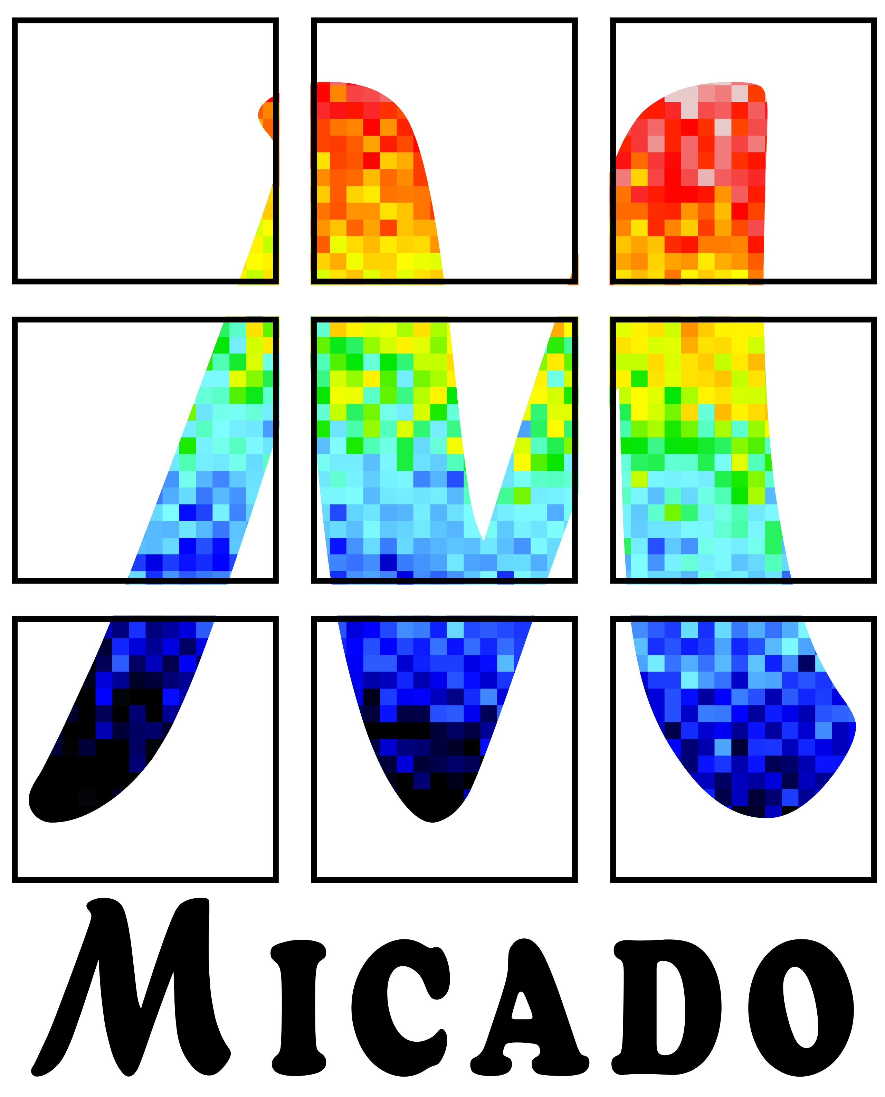

ELT - MICADO

Phase C

**Cables characteristics from ICS06 feedthrough to SCAO WAX and WOK panel**

Doc. No.: ELT-TNO-MCD-56304-0140

Issue: 1.0

Date: 23.12.2023

Author(s): N. Gautherot………23.12.2023…………………..

Name Date Signature

E. Meyer. ………23.12.2023…………………..

Name Date Signature

WP Manager: Y. Clénet …23.12.2023…………………….

Name Date Signature

Proj. Responsible R. Davies ……………………………………………………..

Name Date Signature

CHANGE RECORD

|  |  |  |  |
| --- | --- | --- | --- |
| ISSUE | DATE | SECTION/PARAGRAPH AFFECTED | REASON/INITIATION DOCUMENTS/REMARKS |
| 1.0 | 23.12.2023 | All | Initial issue |
|  |  |  |  |
|  |  |  |  |
|  |  |  |  |
|  |  |  |  |
|  |  |  |  |
|  |  |  |  |
|  |  |  |  |
|  |  |  |  |
|  |  |  |  |
|  |  |  |  |
|  |  |  |  |
|  |  |  |  |
|  |  |  |  |

**TABLE OF CONTENTS**

1. Introduction 4

2. Cables characteristics 4

# Introduction

This document lists the cables characteristics from the ICS06 feedthrough to the SCAO WAX and WOK panels of SCAO

# Cables characteristics

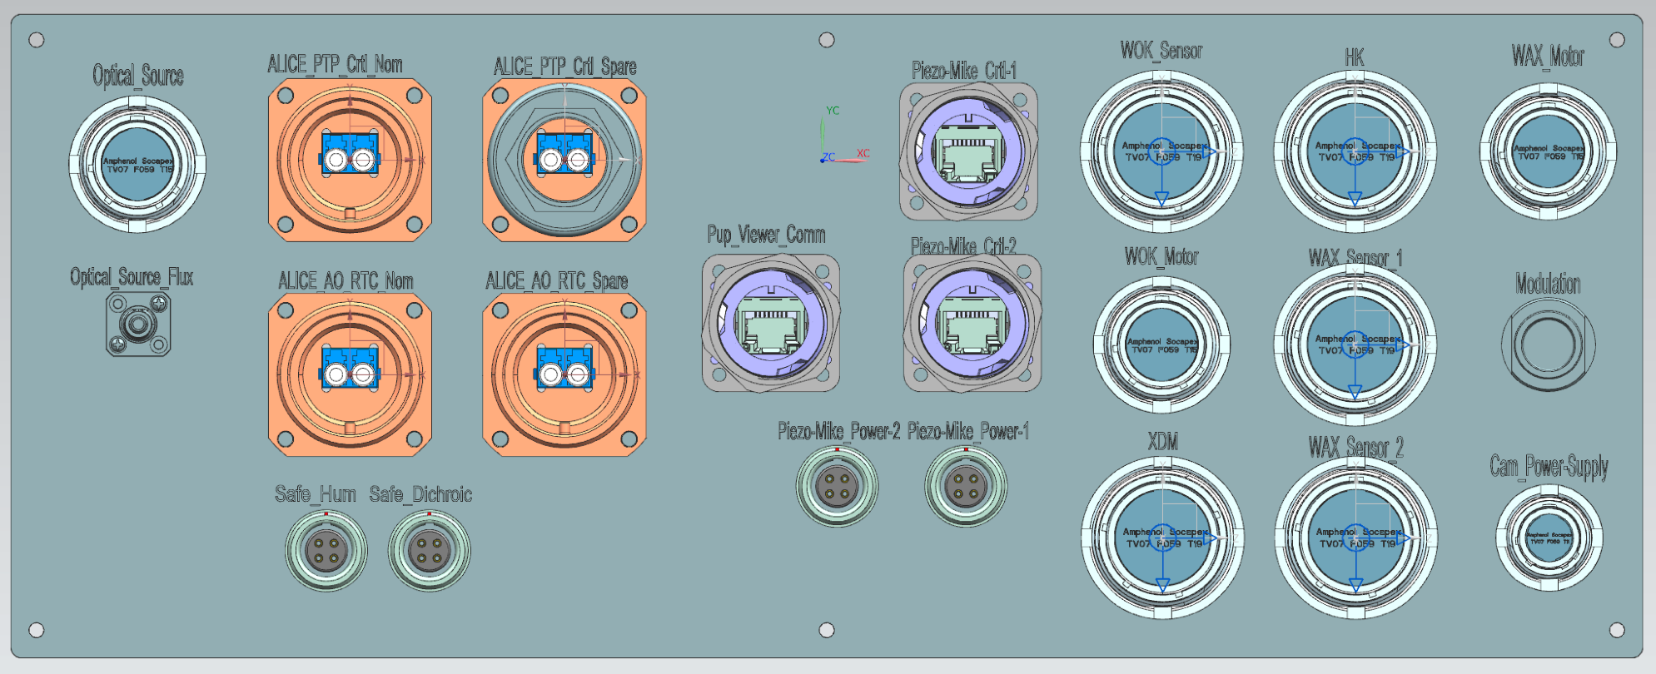

Figure 1: ICS06 feedthrough

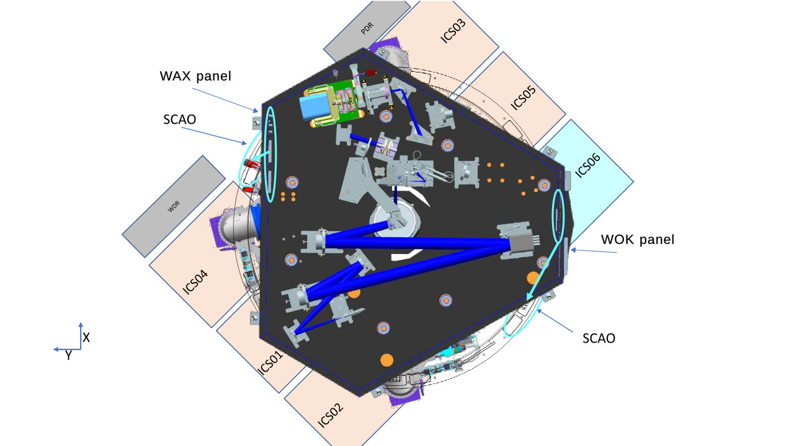

Figure 2: SCAO top view figuring ICS06 and the WAX and WOK panels locations

|  |  |  |  |  |  |  |
| --- | --- | --- | --- | --- | --- | --- |
| Designation | Type of signal | Reference | Cable diameter (mm) | Connector diameter (mm) | Destination | Longueur (mm) |
| WAX Sensor 1 | Sensor In | TV07 ZN 19-88 S_F472 | 28 | 38,5 | WAX | 6700 |
| WAX Sensor 2 | Sensor In | TV07 ZN 19-88 S_F472 | 28 | 38,5 | WAX | 6700 |
| WAX Motor | Motor Out | TV07 ZN 15-55 S_F472 | 22 | 32,5 | WAX | 6700 |
| WOK Sensor | Sensor In | TV07 ZN 19-88 S_F472 | 28 | 38,5 | WOK | 7000 |
| WOK Motor | Motor Out | TV07 ZN 15-55 S_F472 | 22 | 32,5 | WOK | 7000 |
| XDM | Actuator Out | TV07 ZN 19-88 P_F472 | 28 | 38,5 | WOK | 7000 |
| HK | Sensor In | TV07 ZN 19-88 S_F472 | 28 | 38,5 | WOK | 7000 |
| Optical source | Power-supply Out, Sensor In | TV07 ZN 15-55 S_F472 | 22 | 32,5 | WOK | 7000 |
| ALICE power-supply and synchro | Power In, Synchro In | TV07 ZN 13-26 S_F472 | 18 | 29,4 | WAX | 6700 |
| Modulation | Piezo In | WDE104 AZ086-120 | 9 | 16 | WAX | 6700 |
| Optical Flux | Flux out | FCPC ADAFC2 | 2 | 10 | WOK | 7000 |
| ALICE AO-RTC RT  NOMINAL | Optical | TOC Bulkhead Set IP68 LC Duplex Telegartner 100007403 | 5 | 36 | WAX | 6700 |
| ALICE AO-RTC RT  SPARE | Optical | TOC Bulkhead Set IP68 LC Duplex Telegartner 100007403 | 5 | 36 | WAX | 6700 |
| ALICE PTP Ctrl  NOMINAL | Optical out | TOC Bulkhead Set IP68 LC Duplex Telegartner 100007403 | 5 | 36 | WAX | 6700 |
| ALICE PTP Ctrl  SPARE | Optical out | TOC Bulkhead Set IP68 LC Duplex Telegartner 100007403 | 5 | 36 | WAX | 6700 |
| Pup Viewer Comm | Ethernet | STX-V1 bulkhead set RJ45 coupler Cat.6 Telegartner 100007415 | 10 | 30 | WAX | 6700 |
| Piezo-Mike Power 1 | Power-supply | M8 Phoenix Male 4 poles | 5 | 10 | WOK | 7000 |
| Piezo-Mike Ctrl 1 | EtherCat | STX-V1 bulkhead set RJ45 coupler Cat.6 Telegartner 100007415 | 10 | 30 | WOK | 7000 |
| Piezo-Mike Power 2 | Power-supply | M8 Phoenix Male 4 poles | 5 | 10 | WOK | 7000 |
| Piezo-Mike Ctrl 2 | EtherCat | STX-V1 bulkhead set RJ45 coupler Cat.6 Telegartner 100007415 | 10 | 30 | WOK | 7000 |
| Safety Humidity | Sensor In | M12 Phoenix Female 4 poles | 5 | 15 | WOK | 7000 |
| Safety Dichroic | Sensor In | M12 Phoenix Female 4 poles | 5 | 15 | WOK | 7000 |

**End of document**